Open Education
39 April 23, 2016

If you want to change student learning then change the methods of assessment
Chuckett and Sutherland

Curriculum alignment

Curriculum is at the heart of school operations; from time to time it needs review and probably realignment. That’s not unusual but it should not be left untended. An examination of the current model suggests that someone forgot to attach the ends. The confusion arises in part because outcome based education is not well defined.

There are a number of approaches to developing outcome based curriculum:
- Outcome based Education (OBE) which starts with « overarching » outcomes and follows all the way down to learners
- Curriculum outcomes which convert school subjects to an outcomes format
- Competency based education which starts with an identification of the competencies needed or desired by a person to function in life’s many roles.

Most Canadian schools, perhaps all, have adopted the middle model; they’ve taken the desired curriculum and reworked it into an outcomes model. In adopting the model, three important elements are missing, (1) the linkage to “overarching” educational outcomes for the Province, (2) the linkage (relevance) to life outside schools and (3) the bridge to students.

Our desire for efficiency leads us to adopt curriculum materials developed by the Western and Northern Canadian Protocal; in the interest of improving effectiveness, we should examine other sources or develop our own.

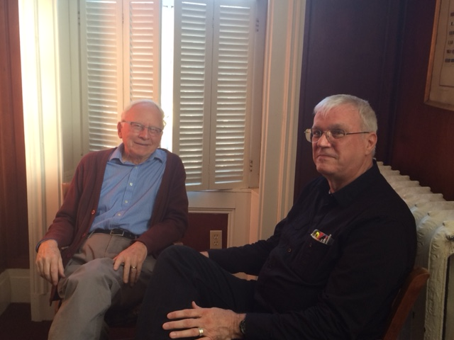
Don Glendenning and Tom White-Hassler
continue the discussion after a recent meeting

Effectiveness or efficiency
A couple of items caught my eye recently. One was an announcement from Ontario about reading specialists being added to schools; the other was about converting 32 administrative positions to teaching positions in PEI. Both are examples of increasing efficiency but not necessarily increasing effectiveness.

Literacy for the 21st century
Keep an eye out for a presentation about PEI results on the Programme for the International Assessment of Adult Competencies (PIAAC). The presentation will provide information on where PEI stands compared to the rest of Canada, and, in particular, to other Atlantic provinces.

Don Glendenning, Editor
Education 20/20 Inc.
101 Kent St., PO Box 624 / 101, rue Kent, B.P. 624
Charlottetown, PEI / Charlottetown (Î.-P.-É.) C1A 1M0
Tel./Tél. : 902-892-2060,
Email/Courriel : pei@education2020.ca
URL : www.education2020.ca

